Process Automation

Statement of Work No. SYN-1118-AR

For



July 1, 2019

Synectiks Inc.
300 Alexander Park Drive, Suite 215
Princeton, NJ 08540
USA

Contents
1. Introduction 3
2. Engagement Overview 3
3. SYNECTIKS Automation Service 3
4. Solution Stack 3
1. Scope of Work 4
2. Project Management & Deliverables 4
3. Assumptions 5
4. Responsibilities 6
5. Change Order Process 7
6. Out of Scope 7
7. Miscellaneous 7
8. Estimated Cost 8
9. SOW Acceptance 8

Introduction

This Statement of Work (“SOW”) is entered into as of the date of last signature (“Effective Date”) by and between Synectiks Inc., (“SYNECTIKS”), a New Jersey Corporation, located at 300 Alexander Park Drive, Suite 215, Princeton, NJ 08540, and Argus Research (“Customer”), located at 61 Broadway, 19th Floor, New York, NY 10006 pursuant to that certain Professional Services by and between the Parties and dated July 1, 2019.

To the extent there are any conflicts or inconsistencies between this SOW and the requirements of Argus Research, both the parties will negotiate in good faith to resolve the differences, the provisions of this SOW shall govern and control, but only with respect to this SOW. The headings and capitalized terms used herein are for convenience only and have no legal effect and shall not in any way define or limit the scope of this agreement.

Engagement Overview

The SYNECTIKS Automation and Analytics service is designed to automate identified Customers operation processes and deliver business insights. Synectiks will work in conjunction with Customer to automate their data processing process and host the automation platform stack in cloud with business analytics tool to gain a business insights.

SYNECTIKS Automation Service

The SYNECTIKS Automation Service provides companies with the services they need to automate their business processes and get value of their data as business insights so that they can take appropriate business decisions.

Solution Stack

The solution stack for automation and analytics are as follows:
- Apache NIFI – Used for Data flows and validations
- Influxdb – Stores Realtime data
- Postgresql database – Stores the business data for OLAP analysis
- Realtime analytics and alerting platform from synectiks

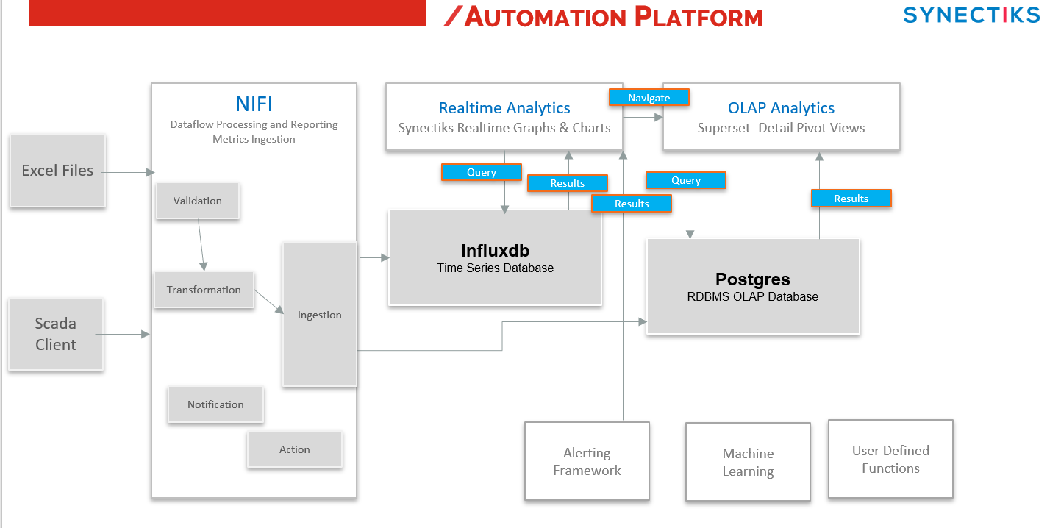

Key technical consideration –

- The input excel DGR files will have only incremental records.
- The system should be capable of tracing any ingestion job status (success failure).
- The system should be capable of sending notification when any job upload fails.

Scope of Work

SYNECTIKS will provide its automation and analytics services to the Customer. The SYNECTIKS Process Automation Services will be executed based upon information provided by the Customer, including detailed information of the business processes automation and business process insights. SYNECTIKS will rely on the information provided by the Customer and the automation schedule may be affected if information is incomplete, inaccurate or out of date.

Process Automation Services Outline

  - Work with Customer to identify the data processing requirement
  - Validate a business insight requirement in conjunction with Customer
  - Deploy the complete solution stack in Azure Cloud platform
  - Implement automation workflows
  - Implement the business analytics as mentioned in specification

  - Assist the Customer with final transition
  - Review completed project

Customer has provided the below Scope of Work to SYNECTIKS during initial conversations.

Automate the data ingestion process of 4 different sites and consolidate the data in database and thereby create analytics reports pertaining to key sla’s of daily generation process and its corresponding KPA’s.

Project Management & Deliverables

A SYNECTIKS Project Manager will schedule, coordinate and assist SYNECTIKS personnel assigned to the Process Automation Services Project. The Project Manager will communicate regularly with SYNECTIKS personnel and be the single point of contact with the Customer’s assigned personnel to manage the project.

The following tasks will be performed as part of the Process Automation Services.

Project Management

  - Coordinate Project Kickoff Meeting
    - Review requisite documentation required for the Cloud Migration
    - Discuss objectives, and level of engagement required by various Customer business owners, IT staff and SYNECTIKS personnel
  - Create and maintain responsibility for the Project Plan/Schedule if needed
  - Coordination of all SYNECTIKS resources required to complete the Project
  - Provide Project status updates as needed
  - Schedule and conduct Project calls as needed
  - Schedule and conduct Project Closing call

Automation Road Map & Outcomes

- Phase 1: Requirement Gathering – 1Week
  - Understand each of KPA metrics details with ecoren team and document their evaluation process.
  - Write detail specification of data flow and its validation criterion
  - Write detail specification of analytics reports and approve with customers

- Phase 2: System setup & Automation – 1 Week
  - Provision entire automation stack and its components in Azure cloud with automation scripts
- Phase 3: Automation & Analytics – 4 Week
  - Data Flow Automation
  - Create business analytics reports as agreed with customer.
- Phase 4: Test and Verification – 1 Week
  - Perform Performance and User Acceptance Tests to verify that solution met the desired SLA’s

- Phase 5: Training & Transition – 1 Week
  - Provide Training & Transition to Customer Personnel

Assumptions

SYNECTIKS fees, project schedule, and Deliverables are contingent upon the Customer’s and SYNECTIKS performance of their respective responsibilities and the assumptions set forth below. To the extent (i) Customer does not meet its obligations under the Agreement or this SOW, (ii) the applicable requirements and specifications change, or (iii) the assumptions listed below are not accurate, and as a result SYNECTIKS ability to perform its obligations in accordance with this SOW or the Agreement is adversely impacted, or additional Services are required to perform the revised scope, then the timelines and milestone dates shall be reasonably adjusted and any additional services required as a result of 7.1(i), (ii) or (iii) above shall be billed to, and paid for by Customer at SYNECTIKS standard rates on a time and materials basis. SYNECTIKS has made the following assumptions in preparing this SOW:

  - General

- Customer representatives shall be available as necessary to, among other things, attend meetings, provide feedback, approve deliverables, validate findings, and test Deliverables as appropriate.
- As work progresses, there may be changes and/or clarifications to the requirements that may impact deadlines and costs. Changes to the scope, schedule and cost of this SOW can be made at any time by agreement of the parties.
- It is assumed that the Services under this SOW shall proceed continuously and there shall be no work interruptions or stoppages ordered other than as may be contemplated by a project plan (if applicable).
Any delay to the start of Services under this SOW which is not under the control of SYNECTIKS, including, but not limited to, delays in approvals, procurement or staff availability, may require an adjustment of fees and expenses and/or the Project schedule for completion of the Services under this SOW.

  - Project Specific

- Customer shall provide SYNECTIKS access to all necessary workstations, servers, data and telecommunications facilities and equipment in a timely fashion. In addition, Customer shall timely provide [any consents, approvals and authorizations necessary to allow SYNECTIKS to use products and services provided under Customer’s third-party contracts which are necessary to enable SYNECTIKS to perform the Services.] Instruction: This description of the Customer’s support activities should be more specific if there is more information on what specific agreements, licenses, etc. need to be signed.
- Tasks, meetings, and reviews that require the input of Customer personnel may impact delivery and costs of SYNECTIKS deliverables if not met within the scheduled timeframes.
- Unless otherwise specified above or in a project schedule agreed by the parties, SYNECTIKS consultants will work an average of forty (40) hours per week on the Project.

Responsibilities

The following outlines each party's responsibilities in making this SOW a success.

  - SYNECTIKS Responsibilities

SYNECTIKS shall provide an SYNECTIKS Contact Person in Paragraph 8 of this SOW who will serve as the primary point of contact with the Customer team and who will coordinate all activities of the SYNECTIKS engagement team. SYNECTIKS resources will provide a weekly status report to the Customer Project Manager using a reporting format defined in conjunction with Customer. SYNECTIKS will include in each status report issues that could result in schedule and cost changes, or issues that may be deferred to a subsequent SOW due to the actual level of Customer staffing, changes in functionality and other unplanned changes.

  - Customer Responsibilities

Customer shall name the Customer Project Manager in Paragraph 10 of this SOW. The Customer Project Manager shall serve as the primary point of contact with the SYNECTIKS engagement team and shall be the Customer’s decision-maker for this Project. In order to provide the Deliverables in accordance with the indicated timeframe, SYNECTIKS requires that the Customer Project Manager be available in a timely manner to participate in all necessary meetings and respond to information requests in a timely manner, specifically: information requests within one (1) business day, and reviews of documents for feedback or sign-off within two (2) business days. The Customer Project Manager shall also coordinate Customer participation during the Project and timely access to Customer resources and information.

In the event that the SYNECTIKS Contact Person or the Customer Project Manager changes, the parties shall amend this SOW to reflect the change.

  - Third-Party Software and Services

Customer acknowledges that certain functionality and performance of the Services and Deliverables may be dependent upon the availability and performance of third-party software and services. Customer agrees that such third-party software and services are subject to the terms and conditions of separate license(s) and services agreement(s) solely between Customer and such third-party provider, and are outside the control of SYNECTIKS. SYNECTIKS specifically disclaims any warranty or liability with respect to such third-party software and services.

Change Order Process

All Material Changes made to this SOW shall be documented in a written Change Order. For purposes of this SOW, a Material Change shall mean any change arising as a result of: (i) incorrect or incomplete information or documentation provided to SYNECTIKS by Customer, (ii) delays caused by Customer, (iii) revisions to the business or technical requirements and/or design specification by either party that also increases the estimated scope, schedule and/or cost of the Project. The parties will informally discuss any proposed change and the party that would like to adopt the change shall submit its request to the other party in writing. SYNECTIKS will include in any proposed Change Order (or in its response to a Customer Change Order) its comments on the requested change including as to technical feasibility and any consequential changes to the scope, schedule, and/or cost of the Project. If the parties agree to the change, this shall be recorded in writing and signed by the parties as a Change Order. The parties shall not be bound by a change or variation until a Change Order has been fully executed. For the avoidance of doubt, such Change Order shall also be governed by the terms and conditions set out in the PSA. Customer acknowledges that a Change Order may result in additional cost to Customer and that such amount is outside of the fixed price quoted above.

Out of Scope

The following activities are out of scope:

- Any maintenance activity after final transition. Annual maintenance will fall under the purview of separate maintenance contract
- End User coordination

Miscellaneous

Customer Project Manager:
Contact Person for this SOW: [Customer Project Manager]
e-mail: [Customer Project Manager e-mail]
Alternate Customer contact person is: [Customer Alternate Contact]
e-mail: [Customer Alternate Contact e-mail]

Customer Accounts Payable Contact:
Customer Contact Person: [Customer AP Contact]
e-mail: [Customer AP Contact e-mail]

SYNECTIKS Contact:
SNECTIKS Contact: [SYNECTIKS Contact]
e-mail: [SYNECTIS Contact e-mail]

Order Date: The term “Order Date” for this Statement of Work shall mean the date this Statement of Work is signed by SYNECTIKS.

In the delivery of the service, SYNECTIKS makes the following assumptions:

- IM (skype for Business) will be provided with necessary Customer IT and Business contacts to report any necessary information during the Project
- Customer will respond in a timely manner to request for information. Any delays may cause delays in the agreed timeline
- Project will begin after the SOW is Signed, on a mutually agreeable date
- If there is a schedule delay not exclusively caused by SYNECTIKS, or a change of scope or deliverables, there may be a mutually agreed to price increase

The headings used in this Agreement are for convenience only and have no legal effect and shall not in any way define or limit the scope of this Agreement.

Estimated Cost

The Services under this SOW will be performed on a time and materials basis. SYNECTIKS initial estimate of effort and professional fees to perform complete PHASES is identified in the following table. The LoE to perform the complete automation is an estimate only, and is subject to change
in case the scope of work is changed.

Man Month Effort:

Role | Rate (USD) | Estimated LoE (Hours) | Estimated Cost
DevOps engineer | $15.00 | 350 | 5250$

SOW Acceptance

As a duly authorized representative, I hereby acknowledge, accept and authorize this Statement of Work.

Accepted & Agreed To:
[Customer - Full Corp. Name] | SYNECTIKS, Inc.
Signature: | Signature:
Name: [Customer Contact Name] | Name: [SYNECTIKS Contact Name]
Title: [Customer Contact Title] | Title: [SYNECTIKS Contact Title]
Date: 7/1/2019 | Date: 7/1/2019

